Lendigo’s Mobile Banking App ER Diagram and Conceptual Design

By Marzan Chowa

Report Outline:

1. Introduction .................................................................................. 3
2. Conceptual Entity Relationship Diagram (Task 1) ......................... 4
3. Detailed Entity Relationship Diagram (Task 2) .............................. 5
4. Overview and specifications based on ER diagram (Task 3) .......... 6
5. Conclusion .................................................................................... 11
6. Reference List ............................................................................... 12

Introduction

**Task 1: Conceptual Entity Relationship Diagram**

The given case study identifies several entities and relationships for Lendigo’s mobile banking system. A simple conceptual entity relationship diagram has been created using the identified primary entities and relationships:

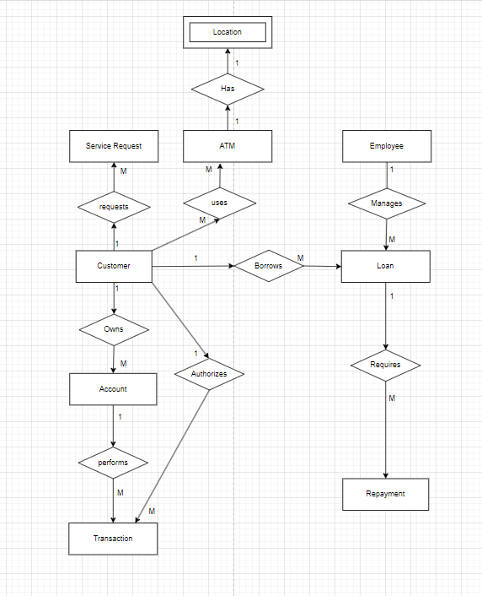

**Task 2: Detailed ER Diagram**

In this task the initial conceptual ER model is expanded into a detailed ER diagram that includes attributes for each entity and the cardinalities between them. A detailed diagram with key attributes for each entity has been created using draw.io:

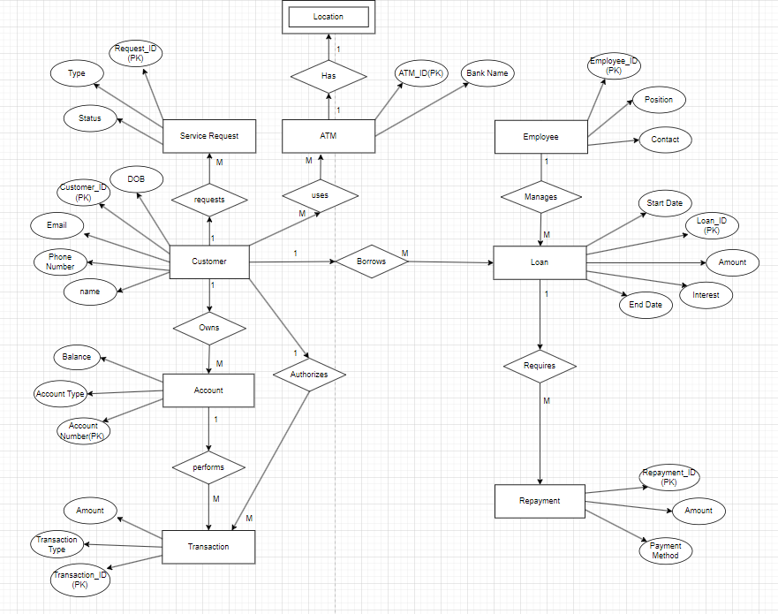

**Task 3: Written Specification for the ER Diagrams**

In task 1 a basic conceptual ER diagram was created identifying the primary entities for Lendigo’s mobile banking system. The primary entities identified from the case study to build the conceptual ER model are as follows:

Customer- Users of Lendigo’s new mobile banking system.

Account- Each customer usually has one or more banking accounts.

Transaction- All kinds of fund transfers, bill payments, recharges and so on using the system.

Loan- To manage and repay and view details of loan information for the customer.

Repayment- The monthly payments made towards any loan borrowed by the customer.

Employee- Represents the Lendigo staff who handle client interactions and loan approvals.

ATM- Represents the ATMs found using the mobile app's location finder.

Service Request- Customers can request services, such as a PIN change or a complaint

Location- A weak entity for various ATMs and their locations.

The relationships between the entities have been identified using 1 and M in the diagram. The relationships identified to build the conceptual ER diagram are as follows:

1 customer can have many accounts - 1 to M

1 customer can authorize many transactions – 1 to M

1 customer can borrow many loans – 1 to M

1 Loan requires many repayments – 1 to M

1 account can have many transactions- 1 to M

1 customer can request many service requests –1 to M

Many employees manage many Loans – M to M

Many customers use many ATMs – M to M

1 ATM has only 1 location – 1 to 1

**Primary Keys (PKs) and Foreign Keys (FKs)**:

Customer:

PK- Customer ID

Account:

PK- Account Number

FK- Customer ID

Transaction:

PK- Transaction ID

FK- Account Number

Loan:

PK- Loan ID

FK- Customer ID

Repayment:

PK- Repayment ID

FK: Loan ID

Staff:

PK- Staff ID

ATM:

PK- ATM ID

Service Request:

PK- Request ID

FK: Customer ID

In task 2, a detailed ER diagram using Attributes has been created. The ER diagram specifies relationships between various entities, including their cardinalities and constraints. This detailed ER diagram reflects how data is interconnected within the mobile banking system and lays the foundation for the database's implementation. This section focuses on explaining the relationships between the entities in plain English:

**Customer**

Attributes: Customer ID, Name, Address, contact, Email, and Date of Birth.

Relationships: Each customer owns 1 or more Accounts, each customer authorizes more than 1 transaction, 1 customer can borrow more than 1 loan, each customer can request more than 1 service request, many customers can use many ATMs.

**Account**

Attributes: Account Number, Account Type, Balance.

Relationships: Each account can perform many transactions

**Transaction:**

Attributes: Transaction_ID, Date, Amount, Transaction Type.

Relationships: Each transaction is associated with 1 account.

**Loan**:

Attributes: Loan_ID, Amount, Interest, Start Date, End Date.

Relationships: Each loan has many repayments; each loan belongs to 1 customer.

**Repayment**:

Attributes: Repayment ID, Amount, Payment Method.

Relationships: Each repayment is linked to a loan

**Employee:**

Attributes: Employee_ID, Position, Contact Details.

Relationships: Staff members are responsible for managing customer accounts and loans (N:1).

**ATM**:

Attributes: ATM ID, Bank Name.

Relationships: Customers can use the ATM locator feature to find nearby ATMs

**Service Request**:

Attributes: Request ID, Request Type (PIN Change, Complaint), Status

Relationships: Each customer can submit multiple service requests

**Detailed relationships between the entities:**

**Customer and Account**: Each customer can have one or more bank accounts. Each account is uniquely linked to a customer. A customer’s account will store their balance and transaction history.

**Customer and Transaction**: A customer can initiate multiple transactions. Transactions can involve fund transfers, bill payments, or mobile recharges. Transactions are always associated with an account, reflecting an M to 1 relationship where many transactions can be associated with one account.

**Customer and Loan**: Customers can take out multiple loans, each associated with specific details such as loan type, amount, and interest rate. Each loan will have multiple repayments until it is closed.

**Loan and Repayment**: Each loan can have multiple repayments. The repayments record details of the amount paid, the method of payment, and the date of the repayment. This relationship is crucial to tracking loan balances and customer compliance with repayment schedules.

**Staff and Loan**: A staff member is responsible for overseeing and managing customer loans. This includes approving or rejecting loan applications and monitoring repayment activities. A staff member can manage multiple loans, but each loan has one assigned staff member, forming a 1 relationship.

**Customer and Service Request**: Customers can submit multiple service requests such as PIN changes or complaints. Each request will be tracked through the system with its unique request ID, and the system will maintain the status of each request (open, in progress, or closed). The cardinality here is 1, as each customer can submit multiple requests.

**ATM and Customer**: Customers can use the mobile banking app to locate ATMs. The ATM locator will display nearby ATMs based on the customer’s location. This relationship is optional for the customer and typically a 1 relationship since multiple customers can use the ATM locator service.

**Strong and weak Relationships**:

* Customer and Account form a strong relationship since accounts cannot exist independently of customers.
* Loan and Repayment also form a strong relationship, as repayments depend on loans.

#### Conclusion

This report has outlined the database design for Lendigo's mobile banking system, aimed at digitizing the company's processes and offering mobile banking services to customers. The conceptual and detailed ER diagrams capture the core entities and their relationships, such as customers, accounts, loans, transactions, and staff management.

Additionally, the written specification explains the relationships, cardinalities, and participation constraints necessary to implement the database. This design will enable Lendigo to efficiently manage customer data, facilitate mobile banking services, and streamline loan management processes.

A number of various features can be added in future versions while keeping up with the proper management of existing services and features to keep the customers happy. Additional database components can be added following the same existing models for expanding the user convenience.

References

[1] BankBazaar, "Mobile banking services: Features and benefits," 2022. [Online]. Available: <https://www.bankbazaar.com/mobile-banking/features-benefits-of-mobile-banking.html>. [Accessed: 13-Oct-2024].

[2] H. Bhasin, "Features of mobile banking and its role in transforming banking services," Marketing91, 2021. [Online]. Available: <https://www.marketing91.com/mobile-banking/>. [Accessed: 13-Oct-2024].

[3] W. Kenton, "Mobile banking definition," Investopedia, 2021. [Online]. Available: <https://www.investopedia.com/terms/m/mobile-banking.asp>. [Accessed: 13-Oct-2024].

[4] V. M. Kumbhar, "Factors affecting the customer satisfaction in e-banking: Some evidences from Indian banks," *Management Research and Practice*, vol. 3, no. 4, pp. 1-15, 2011.

[5] T. Nguyen, "Mobile banking system and its evolution in the digital age," 2020. [Online]. Available: <https://www.mobilebanking.org/evolution-digital-age/>. [Accessed: 13-Oct-2024].

[6] MyHRsite.net, "FBO Login India Login." [Online]. Available: https://myhrsite.net/fbo-login-india-login/. [Accessed: 13-Oct-2024].

[7] I. Hapsari, Z. Parastuty, and C. C. Tjoa, "Design of multichannel retailing pet shop," 2012. [Online]. Available: https://core.ac.uk/download/14342215.pdf. [Accessed: 13-Oct-2024].

[8] OpenAI, "ChatGPT," Version GPT-4, 2024. [Online]. Available: https://chat.openai.com. [Accessed: 13-Oct-2024].